Programme Guide
The programme has two main objectives. To improve access to dental care and the delivery of evidence-based prevention.
Access | Open on NHS Choices  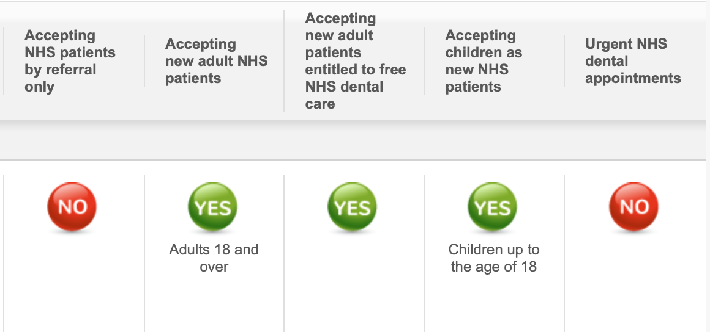  Edit Waiting times in the box  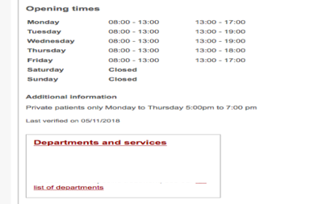
Dental Check by One
Work on developing access for 0-2 through DCby1 Programme
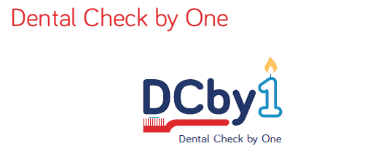
Prevention  Recalls | Universal Evidence Based Prevention  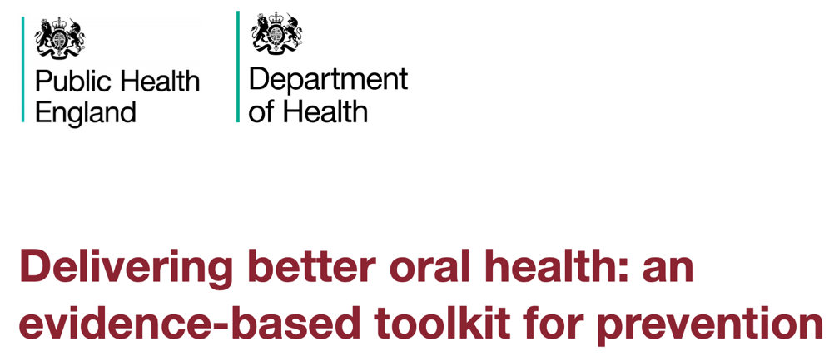
Delivery of Targeted Prevention pathways by trained DCPs or other qualified members of the team.
- Children 0-18 with caries or referred for GA extractions
- Adults with
- Dementia
- Dry Mouth
- MRONJ Risk
- Diabetes
- High needs/Phased Treatment Approach

Follow NICE guidance on dental recall:
https://www.nice.org.uk/guidance/cg19/chapter/1-Guidance

Training | The following EL-FH Modules will improve knowledge to support the programme. All CPD is verifiable and certifiable and can be used within a PDP on Prevention – see resources.  Register for EL-FH - https://portal.e-lfh.org.uk  Go to the Population Wellbeing portal - https://populationwellbeingportal.e-lfh.org.uk/.  Go to the browse catalogue section.  The modules we would like Champions and as many Team members as possible to complete are:  - Oral Health  - Smoking  - The Dental Health Promotion section of the Health Child section of the Child Health module  - Safeguarding Adults – Level 1  - Safeguarding children – Level 1  Additional SW Modules on DBOH and Behaviour Change will be added once these are added to EL-FH.
Working with the Community Dental Services | The CDS Service in your area will contact the Practice about arrangements for the “safe” discharge / referral of level 1 patients from the CDS to Primary dental Care.
Working with the Local Authority | Signposting  The Local Authority Health Visitor and Social Care Teams will be in touch regarding the signposting of mainly 0-2s into the Practice to facilitate the DCby1 Programme for access and prevention.  Was Not Brought Policy  Secondly the Health Visitor and Social Care Teams may on occasion refer children of concern via email and ask you to feedback by email in the vent that these patients are not brought. Local Authorities will contact Practices to share policy documents.
Brief Interventions | Smoking Cessation  https://www.nhs.uk/live-well/quit-smoking/nhs-stop-smoking-services-help-you-quit/  Alcohol awareness  https://assets.publishing.service.gov.uk/government/uploads/system/uploads/attachment_data/file/684828/Fast_alcohol_use_screening_test__FAST__.pdf
MECC Link Referrals
Patients that wish you to ACT and refer for support – use the MECC link to action:
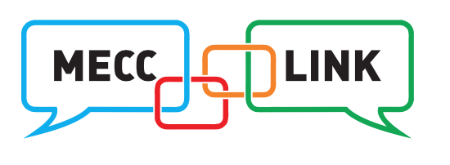

http://www.mecclink.co.uk

Data Collection | Data collection enables NHSE to establish Programme outcomes and Practices to demonstrate compliance and Programme activity. See resources.
Data Submission | Data is submitted quarterly in March , June, September and December using the data submission link – see resources

