Yorkshire and Humber - Prevention Programme Pathway

The e-learning pathway can be accessed by firstly logging on to EL-FH: https://www.e-lfh.org.uk
Then search for e-Den.

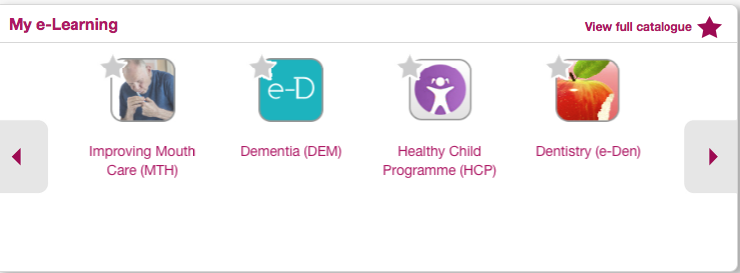

Log in to e-Den and look for e learning path section: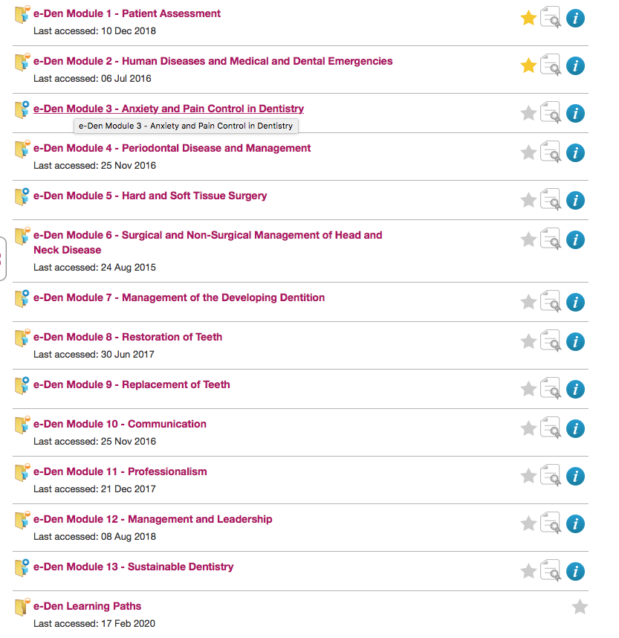

Click on the e-Den learning paths

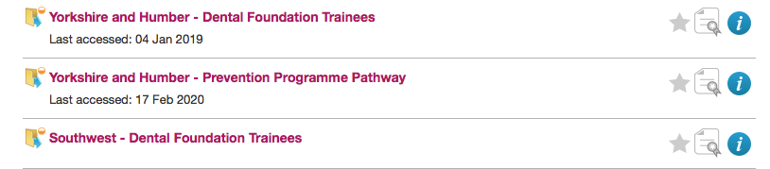
Click on the Yorkshire and Humber - Prevention Programme Pathway

The Children’s oral health section includes three modules:
