Prevention & Access Programme Data Collection & Submission

Data Collection
The data collection spreadsheet or similar should be used in practices to collect programme data that is required to be submitted through the data collection SNAP tool.
Normally this would be collected in each surgery and then each surgery data would be transferred to a whole Practice data sheet so that the total data from each surgery can be submitted.
The total reports are submitted via the SNAP Tool:
https://www.snapsurveys.com/wh/s.asp?k=157243602104

Initially we expect the yes / no answers to include some no responses as Practices develop.

Submissions
This is conducted quarterly in June / September /December/ March
1. Select Practice contract number form the list

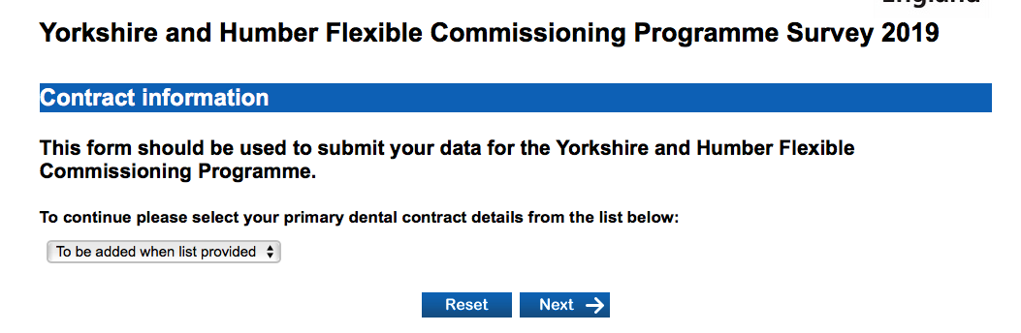
2. Answer the Yes / No questions. The training refers to both the training required by the DCP delivering the targeted prevention pathways and the e learning for the Practice team in general.

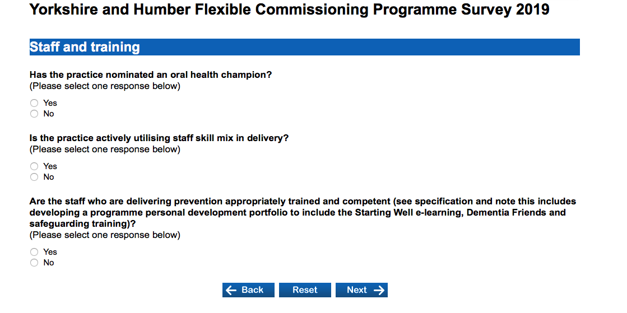

3. Answer the yes / no questions.
The Community Dental Service in your area will contact the Practice about arrangements for the referral of patients that can be treated in Primary Care.
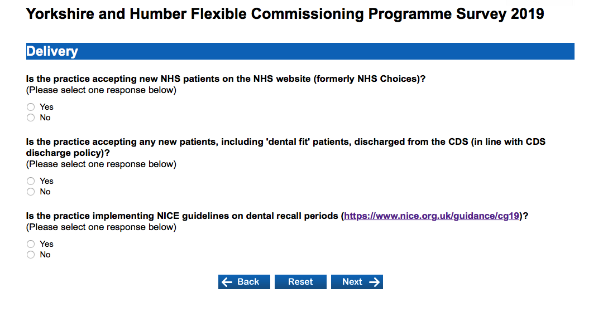

4. Submit the recorded data from the Practice data collection.
Submit the current waiting time for new patients

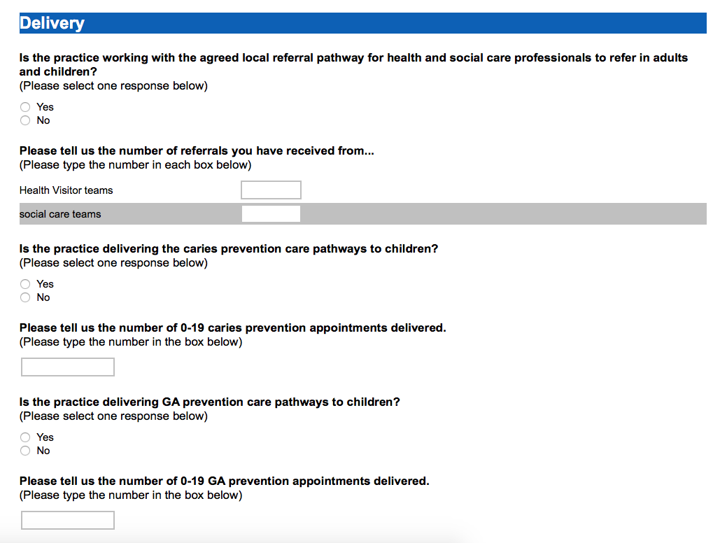

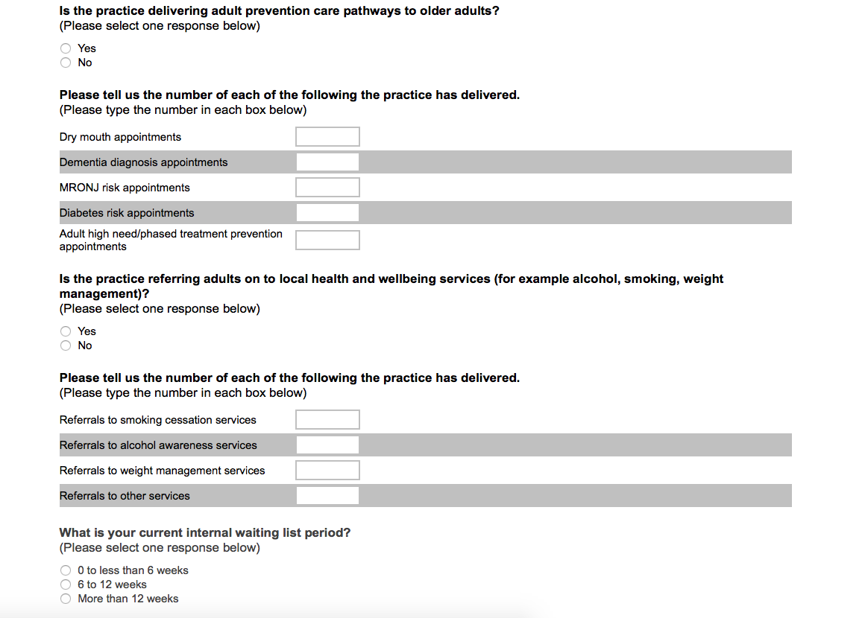

5. Complete the declaration and press submit. 